Lecture No. 18 PARASITOLOGY DR.Raad H.H.
Phylum Platyhelminthes
Class Trematoda ( Fluke worms )
general character :
- All trematodes are parasitic, and most adult trematodes parasitize vertebrates.
- Around 9000 species have been described.
- Their body is covered with a tegument, a peculiar kind of epidermal arrangement in which the main cell bodies are deep, separated from the cytoplasm that lies next to the exterior by a layer of muscle (but connected to the exterior layer by cellular processes. The exterior layer is syncytial; that is, it is continuous, not broken by cell membranes.
- The tegument lacks cilia in adults.
- Unlike monogeneans, trematodes have no opisthoaptor; instead, they are characterized by one or two suckers.
- They are like turbellarians in having a relatively well developed alimentary canal, and their muscular, excretory, and reproductive systems are also relatively complete.
- Most trematodes have complex life cycles, with larval stages parasitizing one or more species that are different from host of adults. Larval stages of some medically important species include miracidium, redia, cercaria, and metacercaria.
- Most trematodes are endoparasites.
- They include several parasites that have an enormous impact on human populations, such as human liver flukes and the blood flukes that cause schistosomiasis.
Class Trematoda contain 3 subclasses :
- Subclass Monogenea ( Trematodes of Fish “ one host “).
- = Aspidogastria ( Trematodes of Fish – snail ).
- = Digenea ( Trematodes of animals & Humans).

Characters of subclass Digenea :
- Leaf like shaped parasites typically flattened dorsoventrally. There are more than 10,000 species of flukes.
- They occur worldwide and range in size from about 5 millimetres (0.2 inch) to several centimetres; most do not exceed 100 millimetres (4 inches) inThe smallest human fluke is Heterophyes heterophyes , while the largest human fluke is Fasciolopsis buski ( 7.5 mm. x 20mm. x 3mm.)
- Flukes vary in shape ; Fasciola is large & fleshy , while others are nearly microscopic like Heterophyes ; still others like Clonorchis , opisthorchis , Dicrocoelium are thin & flabby ; Schistosoma is more or less delicately cylindrical .
- Body covered by resistant cuticle , spiny in Fasciola & smooth in Dicrocoelium .
- There 2 suckers used as attachment’s organs ; the anterior called “oral sucker “ surrounding the mouth , & the “ventral sucker “ or “ Acetabulum “ which located ventrally in fronted part of the body & it is called “posterior sucker “ when located in rear body end. Some flukes also has the “ Genital sucker “. the genital pore situated ventrally between the suckers.
- Flukes are hermaphrodite ( Monoecious) except Schistosoma which are separated sexes ( Diecious) .
- There is no body cavity ,internal organs covered by paranchymatous tissue .
- The Digestive system begins with mouth “oral cavity “ leading to esophagus then intestines which consists of 2 elementary canals blindly ended called “Ceca “ ;nutrition by absorption through cuticle .
- No respiratory or circulatory systems .
- Nervous system consist of 2 pair of nervous nodes & 3 pair of nervous cords ; larval stages possess pair of “eye spot”.
- Excretory system consist of “flame cells” ( Solenocytes) & collecting tubules that gathered and opened in excretory pore .
- Flukes are oviparous ; eggs operculated except eggs of Schistosoma non operculated but possesses spines .
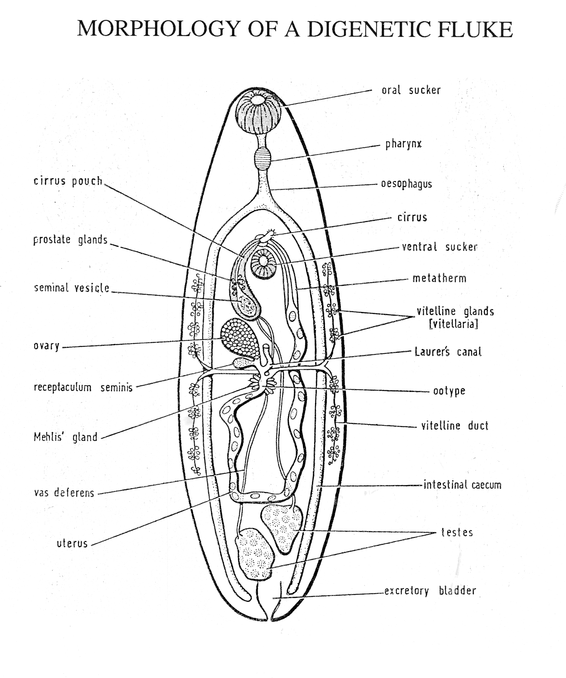

- The reproductive system highly developed ended by common genital pore . Female usually has 1 (single) ovary . Male usually has 2 testes .
Ootype , Mehli’s gland (shell gland ), Laurer’s duct(may act as vagina)
- Life cycle complicated & need 1 or 2 or more intermediate host(I.H.); usually 1st. I.H. is “Snail “ & 2nd. I.H. is "animal" e.g. fish , or "plants" to complete Metacercarian stage .

Stages of life cycle of Trematoda :-
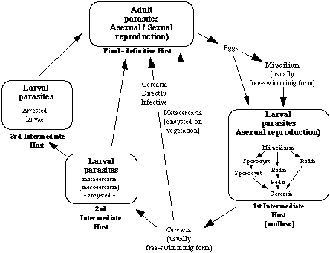

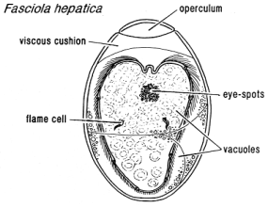
- Eggs have Operculum & either Unembryonated or Embryonated ; it need’s water , O2 & temp. 26 - 32 C.
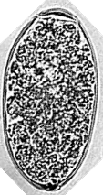

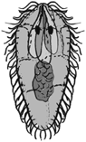
- Miracidium : it is the 1st. larval stage , conical shape covered by cilia & has pair of Eye spots ; has ability to swimming then entering suitable snail .
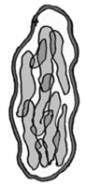
- Sporocyst : it is the 2nd. Larval stage , sac like shape consist of germinal cells ( asexual generation ) ; it is found inside the snail in order to form either 2nd. Sporocyst or Redia .

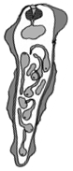

- Redia : it is the 3rd. larval stage , tubular shape ;
may be 5 – 10 # inside the snail ; Redia have
primitive organs , eye spots & germinal cells
which may produce 2nd. Redia or Cercaria .

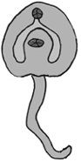
- Cercaria : it is the 4th. Larval stage , discoid shape ; 200 – 400 # ; it have internal organs with long tail used for swimming outside the snail ; it is either find the final host or it is find the 2nd. I.H. ( fishes ; crustacean or plants ) to form metacercaria which is taken finally by the definitive host .
Types of Cercaria tail:-
- Leptocercus type ( simple shape ) e.g. Fasciola .

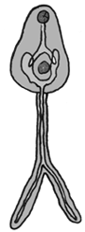
- Ferrocercus ( bifid shape ) e.g. Schistosoma .

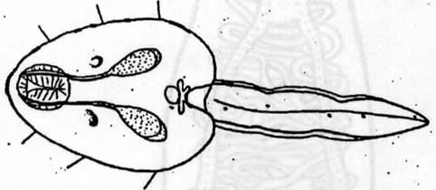
- Lophocercus ( membranous shape ) e.g. Heterophyes .
The Adult Digenean Fluke
The basic body form of the adult trematode takes a number of different forms, some of which are illustrated below;
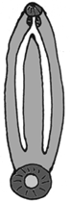 | 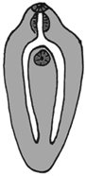 | 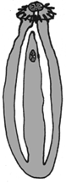 | 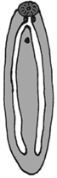
Amphistome | Distome | Echinostome | Monostome
These have large fleshy bodies, with a prominent sucker at the posterior of the body  (e.g. Gastrodiscus aegyptiacus) | These are the most common type, with the mouth surrounded by the oral sucker and a ventral sucker, present anywhere on the ventral surface except the extreme posterior  (e.g. Fasciola hepatica ) | Similar to the distomes, except that the oral sucker surrounded by a prominent collar, equiped with spines  (e.g. Echinostoma sp.) | In these there is either only one sucker present (usually only the oral sucker), or there are two suckers, but one very reduced, or in some cases no suckers)  (e.g. Notocotylus attenuatus )
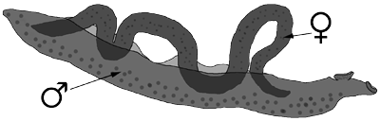
Schistosome
Elongate trematodes, with separate sexes, the male generally larger, holding the female within a groove formed by a folding of the male body (the gynaecophoric canal). Found within the circulatory system. (e.g.Schistosoma mansoni)
There are other forms as well, for example the 'Holostome' type, where the body of the trematode is divided into two distinct regions, the anterior of which may hold an additional adhesive organ, (e.g. Diplostomum sp.), and the 'Gasterostome', where the gut is a very simple, sac like, structure, attached to a mouth situated near the centre of the body (reminiscent of the arangment of some of the free living platyhelminthes).
